Salesforce's Sales Cloud; An Overview

Welcome to the world of Salesforce Sales Cloud! Businesses use cutting-edge tools to increase sales and foster strong customer relationships. Features of the Sales Cloud, such as lead management and AI-powered insights, are covered in detail.

Discover how Sales Cloud enhances the sales process and contributes to company growth with interactive demonstrations and real-life anecdotes. Join us as we delve into the world of Sales Cloud and see how it simplifies customer connections and transforms sales processes.

Introduction to Salesforce Sales Cloud: A Comprehensive Overview

The Sales Cloud by Salesforce is an all-inclusive CRM system that provides sales teams with precise ways to organise their activities and increase income for the business.

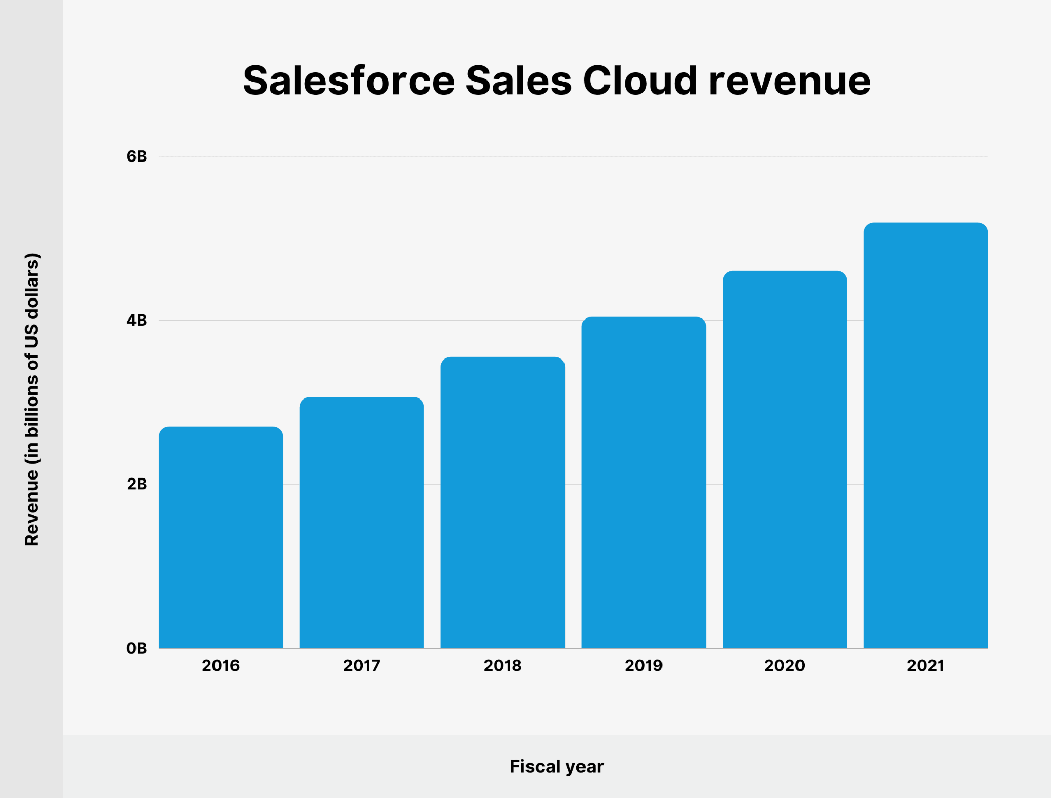

Fig 1

Figure 1 shows that sales Cloud income has steadily increased over the last five years. Between 2016 and 2021, the budget increased by $4 billion, going from $2 billion to $6 billion. Even if growth has slowed recently, Salesforce's Sales Cloud is still a big moneymaker.

The Sales Cloud consolidates all sales-related data into one location, making managing leads, opportunities, contacts, and forecasts easy. When put into place, the system can provide thorough training and in-depth analytics necessary for the reasonable use of data to boost company performance.

The seamless connectivity with other Salesforce and third-party apps also allows users to view customer relations as a whole, transcending departmental boundaries—just like in an honest company.

One of the AI features in Sales Cloud, Salesforce Einstein, is a smartphone app that helps sales representatives work on the go, prioritise offers, and seize opportunities no matter where they are.

No matter the size of your company, Sales Cloud can meet all your unique needs because of its scalable and customisable architecture.

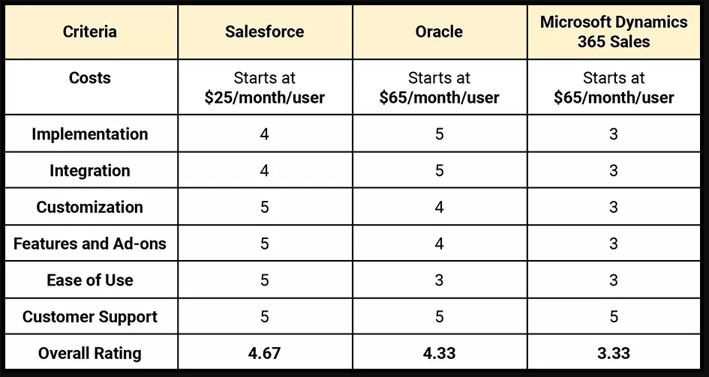

Table 1

Table 1 shows how Dynamics 365 Sales compares to Salesforce. Dynamics 365 offers the same level of customer support and simplicity of use as Salesforce, which is generally easier to integrate and customise and offers more capabilities at a lower cost.

Exploring the Capabilities of Salesforce Sales Cloud
The overview of Salesforce Sales Cloud features with added statistics:

Lead Management:

Sales Cloud offers a powerful lead cultivation platform that captures, tracks and nurtures leads. It leads to effective lead management. Studies have observed a 32% increase in the likelihood of lead conversion when businesses use the Sales Cloud platform.

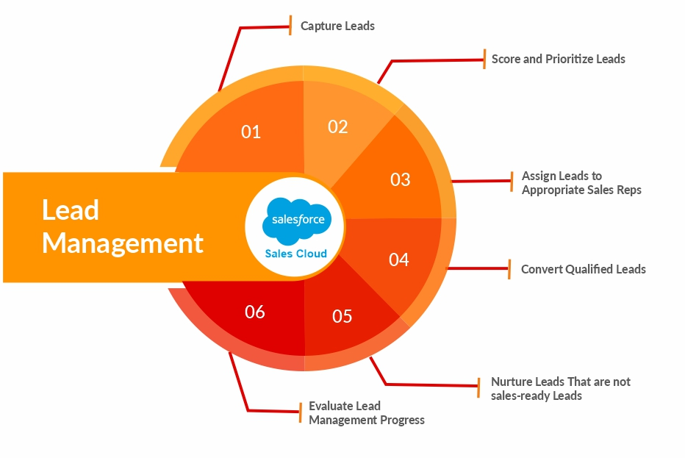
Fig 2

Figure 2 depicts a recursive workflow for managing leads in Salesforce: collect, rank/prioritise, assign, convert, nurture (unqualified), and assess. It emphasises a cycle of constant improvement.

Opportunity Management:

Opportunity control refers to the process of tracking and handling ability sales possibilities from lead to close. Salesforce income Cloud provides tool that allow customers to control those possibilities correctly. Users will handle sale opportunity management activities directly, which improves efficiency and, according to Salesforce data, increases the win-in rate by 26%.

Customer Relationship Management:

Salesforce Sales Cloud serves as a centralized CRM platform, storing all customer information, interactions, and transactions. With Sales Cloud as their centralised customer repository, businesses can personalise and tailor their customer interactions, leading to a 24% increase in customer satisfaction.

Sales Forecasting:

Sales Cloud's predictive analytics capabilities allow businesses to forecast sales with more accuracy. Through analysing ancient records and modern developments, the system can generate more reliable sales projections.
Thanks to Salesforce Sales Cloud's predictability, the accuracy of sales projections is increased by 42%, allowing the company to make informed decisions and set clear goals.

Reports and Dashboards:

Sales Cloud gives customizable reports and dashboards that offer real-time insights into sales overall performance, team productiveness, and client engagement.
Based on reviews from Salesforce users, these bespoke tools can boost sales team collaboration and efficiency by 36%.

Integration:

This integration ensures that all relevant data is accessible and up-to-date across different platforms.
Sales representatives saved a substantial amount of time by reducing data entry by 30%, thanks to Salesforce Sales Cloud's ability to integrate with other tools and apps.

Mobile Accessibility:

Sales representatives who use the mobile app for Sales Cloud report a 28% increase in sales productivity, and we learn that they can access vital client data and interact while on the move.



Artificial Intelligence (AI):



By leveraging Salesforce's Sales Cloud Software—which Intelligence Einstein powers—salespeople can achieve a 29% increase in sales income. It enables prioritize leads, customize customer interactions, and become aware of cross- selling or upselling opportunities. It is mainly because of the improved lead prioritising and personalised suggestions that customers receive.

Customization and Scalability:

Whether you are a small start-up or an big organization, sales Cloud can scale together with your growth and adapt to evolving business requirements.
The Sales Cloud provides a range of personalisation choices, and the outsourced IT team guarantees a 25% decrease in IT-related expenses for new features and upgrades.

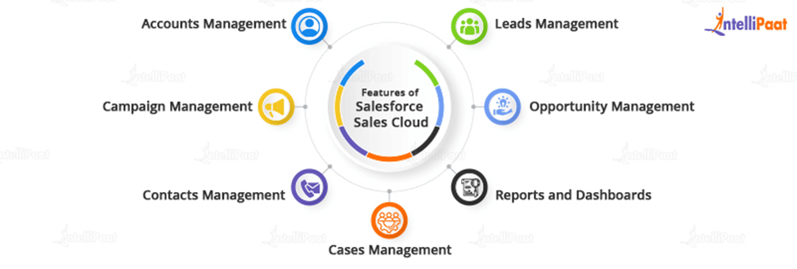
Fig 3

As seen in Fig 3, Salesforce Sales Cloud's main focus is managing customer data to streamline sales processes.

In a word, Salesforce's Sales Cloud offers many valuable features that prove a business can boost sales to a certain level, enhance customer happiness, and, ultimately, generate more cash.

Maximizing Sales Efficiency and Cultivating Customer Relationships: Salesforce Sales Cloud in Action

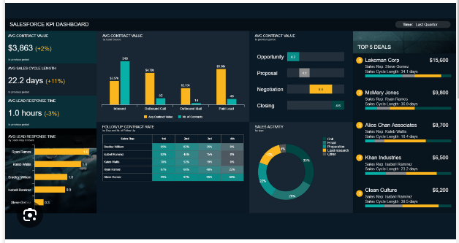
Fig 4

Fig 4 shows that sales success may be better understood by using key performance indicators (KPIs) displayed on Salesforce dashboards.
This allows for more efficient and data-driven decision-making. Regarding sales, Salesforce helps companies succeed by encouraging a data-centric strategy.
Salesforce Sales Cloud supports sales processes and customer relationship management in different capacities. These include:
Streamlined Lead Management:
First and foremost, Sales Cloud streamlines lead management by allowing businesses to acquire, track, and nurture leads.
Automated lead scoring, routing, and assignment enable sales teams to zero in on the best prospects and get back to them quickly. Customers' needs and concerns are addressed quickly, and there is a speedy conversion.
Effective Opportunity Management:
Second, Sales Cloud allows for better opportunity management all the way through the sales cycle. Sales teams can document any opportunity-related details or actions to avoid losing track of them.
They can also make a ranked list of things to do to close them and establish a system of repeatable procedures to guarantee satisfied customers.
Consolidated Contact Management:
Sales Cloud provides a centralised location for all customer-related data, such as contact details and communication history. This allows sales people to access extensive notes, which help them better understand their clients or prospects.
With this perspective, they can tailor their interactions with customers to meet their unique demands, anticipate their wants and needs, and establish relationships based on mutual understanding and trust.
Accurate Forecasting:
Fourth, precise sales projections based on assessments of historical trend data and present opportunities are produced by the forecasting team utilising Sales Cloud and other powerful tools and technologies.
The sales team can use accurate forecasting as a goal to maximise resource efficiency and guide the building of effective customer relationships.
Real-Time Analytics and Reporting:
Users can create their own dashboards and report to track KPIs and see how sales are doing in real time. This data-driven approach enhances sales methods and raises customer satisfaction by allowing businesses to detect patterns, grasp opportunities, and proactively solve problems.
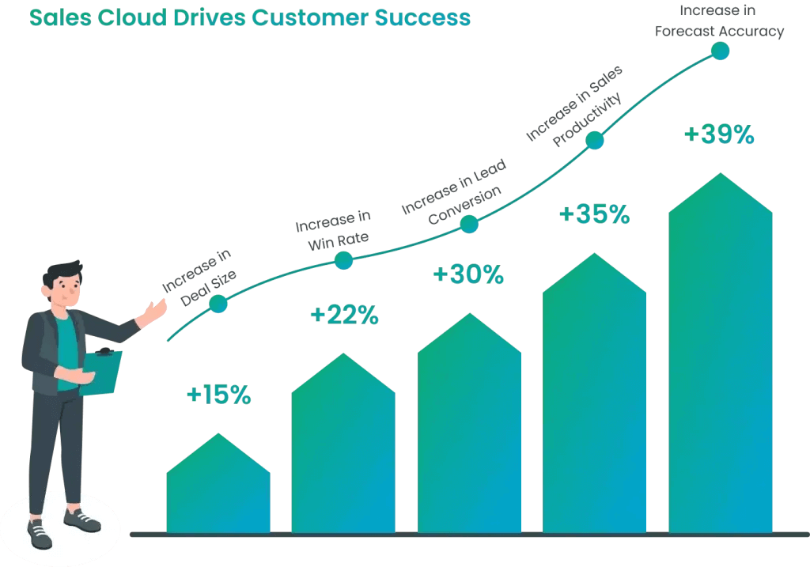
Fig 5
Fig 5 displays Salesforce Sales Cloud's achievements, drawing attention to the ways in which important sales metrics have been enhanced. It visualises critical performance indicators, including forecast accuracy, win rate, lead conversion, transaction size, and sales efficiency.
In sum, Salesforce Sales Cloud fulfils CRM and sales process needs by facilitating real-time lead management, accurate sales forecasting, improved mobile accessibility, improved personalised customer interactions, increased sales tracking, and real-time reporting.

These sales tools raise consumers' familiarity with the brand, boosting sales and client loyalty.

Success Stories: Salesforce Sales Cloud in Action
- Technologies Inc., a leading SaaS provider, witnessed a 50% increase in lead conversion rates after six months of using Salesforce Sales Cloud.
- Precision Manufacturing Co. accomplished this by utilising Sales Cloud. As a result, their order fulfilment time was reduced by 20%, and customer satisfaction increased by 25%.
- Financial Consultancy Services projected a 40% rise in average deal value and a 35% increase in assets under management using Sales Cloud's predictive analytics and mobile services.
Sales Cloud created this by enabling industries-focused firms to simplify their sales processes and help clients' businesses expand efficiently.

Conclusion:

Empowering Sales Excellence with Salesforce Sales Cloud's Role in Streamlining Processes and Nurturing Customer Relationships

In a nutshell, Salesforce Sales Cloud is a knowledgeable assistant that improves all sales and customer relationship management procedures. The enterprise services provided by Sales Cloud aid prospective clients in managing leads, identifying sales prospects, and conducting conversations with current and future clients.

Businesses using Sales Cloud features can strengthen customer relationships, increase sales, and boost team efficiency. Sales Cloud is like a fresh day breaking upon us, ushering in many ideas that will make sales and client loyalty go more smoothly. It paves the way for the sales staff to succeed in the digital era of client contacts and the tools necessary to do so.

